Detecting Misconduct Incidences in Trading Floor Communications
Background Theory
- FMSB Annual Report 2017 (FICC Markets Standards Board)
- BNM, Code of Conduct for Malaysian Wholesale Financial Markets, 2017
- Singapore Blue Book (Guide to Conduct & Market practice for Treasury Activities) July 2013
Examples of Misconduct Modalities:
- Influencing the Market: Trying to influence products traded / market price (up or down)
  - Making unsubstantiated statements or sharing false information
  - Placing quotes for products and then cancelling them repeatedly
  - Placing staggered buy / sell orders at different price levels for the same product
  - Colluding with others to fix the price or price range for products
  - Placing one-way quotes (buy or sell) for a product on the same day repeatedly without executing any transactions even when that product is actively traded in the market
  - Executing an opposite trade (place buy quotes and execute a sell transaction or vice versa)
- Front-Running: Buying / Selling a product for which there is a large Client order, before executing the Client’s order
- Mark the Market: Buying a small volume of a particular product near closing hours of the market at a price away from the average market price
- Non-approved Business Languages:
  - Conversing in non-business approved languages (maybe to hide what they are doing)
- Codewords:
  - Using code words when discussing deals (trying to hide something from management?)
- Soliciting/Disclosing Confidential Information:
  - Asking for or sharing Confidential Information (MNPI – Material Non-Public Information)
    - Market sensitive information the bank has but not yet announced to the public
    - Trades done by other customers of the bank or the broker
Lab Exercise 1:
Using keyword search techniques, find;
- Use of codewords (naga, askar, tiger)
- Can you find other words which MAY be codewords?
- How would you do it, what approach?
- Show examples of success and examples for FALSE ALARMS
- Comment on the effectiveness of this technique
Technique used:
Used search function in Excel to look for each keyword, highlight each row containing the keywords, then analyse the entire conversation context surrounding the highlighted row to decide whether this is an actual misconduct or false alarm.
Misconduct spotted:
Codeword: naga
Time | Sender | Conversational Message
17/7/2024 2:10:00 pm | Mira Thorne | Hearing rumors Naga might be looking to buy a lot GII next week. Any color? What levels?

Codeword: strawberry
Time | Sender | Conversational Message
18/7/2024 1:12:00 pm | Ben Carter | Need to push the Strawberry price down a bit. Can you flash a huge sell order near the market? Like 20M contracts? Don't intend to trade it. just show size.

False Alarm
Codeword: dragon
Time | Sender | Conversational Message
17/7/2024 3:43:00 pm | Emily Brown | Was working a price on that block of GII 1235 with Dragon. Thought we were basically agreed on level. went to confirm size. and they suddenly backed away completely.

Reason: While "Dragon" sounds like a codeword, in the context of bond trading, it often refers to a specific, well-known counterparty. Tagging this as "secret collusion" would be a false alarm if it is just a complaint about a bank's liquidity.

Drawback of excel search approach
- Many keywords, such as ‘tiger’, do not return any result, it is time consuming to search an exhaustive list of keywords.
- Some keywords may return high proportion of results which are false alarms.
- It is labour intensive to manually analyze all conversational context in order to identify true positives.

Lab Exercise 2:
Using keyword search techniques, find:
- Attempts to solicit (ask for, request for) confidential information
- What techniques will you use?
- What success did you achieve? Show examples.
Technique used:

Misconduct Keywords
To spot certain matched keywords for the types of misconduct, we utilised AI tools to generate
Type of Misconduct | Matched Keywords
Front Running | before the order, client order, ahead of, jump ahead, front, run ahead, beat the client, first mover
Insider Trading | inside, tip, heard from, dont tell, keep quiet, confidential, not public, before announcement, you know what, hot info, got info, got news
Marking the Close | end of day, close price, push up, push down, end of month, fix the close, closing price, settle at, last print, mark
Collusion and Price Fixing | agree on price, same price, let's set, coordinate, between us, fix price, align, match price, naga, askar, tiger, lion, dragon
Wash Trades and Position Parking | park, hold for me, take it back, transfer back, wash, round trip, cross trade, pass it back, warehouse
Spoofing | fake, cancel, pull, spoof, flush, bait, push price, scare, force, trigger, stop loss, flash, show size, hide, layering
Gifts and Entertainment | dinner, lunch, drinks, bottle, gift, ang pow, voucher, treat, hotel, holiday, trip, ticket, concert, owe me, you owe, favour, lobang
Concealment and Ambiguous Language | delete, remove, clean up, dont save, off record, offline, call me, whatsapp, telegram, signal, not here, later talk, face to face, meet up, no trace, careful
Urgency and Pressure Signals | asap, urgent, quickly, fast, now, hurry, immediately, dont wait, no time, rush, must do

Use Excel to search keywords/phrases, such as: “behind the scenes”, “off the record”, “favor / favour”, “axe”.
Time | Sender | Conversational Message
17/7/2024 2:12:00 pm | David Garcia | Yeah. hearing they have a mandate to buy ~500M across the curve. mostly GII 1035. Probably starting tomorrow AM.

Lab Exercise 3:
Repeat the above using Google AI Studio
- Show your technique
- Show your success/failure
- Comment on the effectiveness of these two approaches.
Technique used:
- Build an app using Google AI Studio, the app has function to perform full analysis on an uploaded csv file and identity potential misconducts, or use keyword search and analyse a particular segment of conversational messages.
(app link: https://ai.studio/apps/13b976f4-bce5-4f34-8b6d-2459a77b1a5b)

1. Finding Codewords (naga, askar, tiger)
Search results using codeword: naga
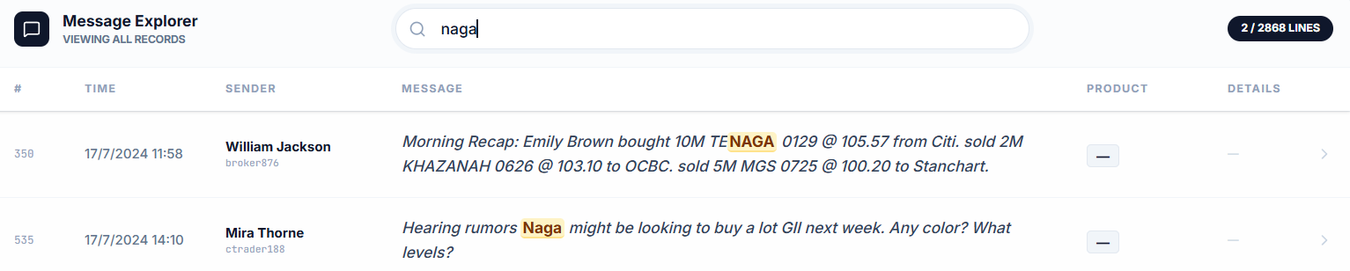
Search results using codeword: askar
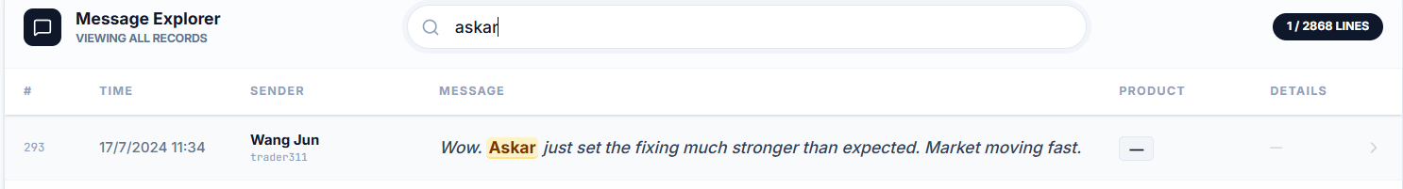
Search results using codeword: tiger
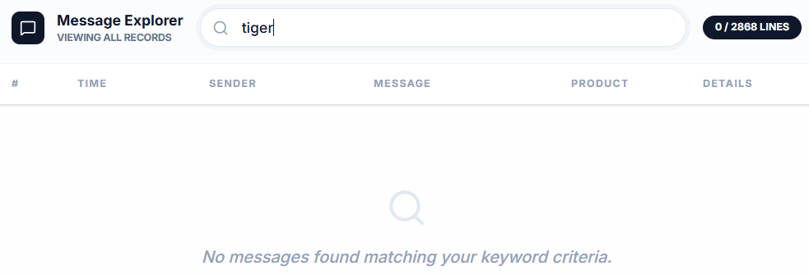
Contextual conversation can be display when clicking on each of the filtered result:
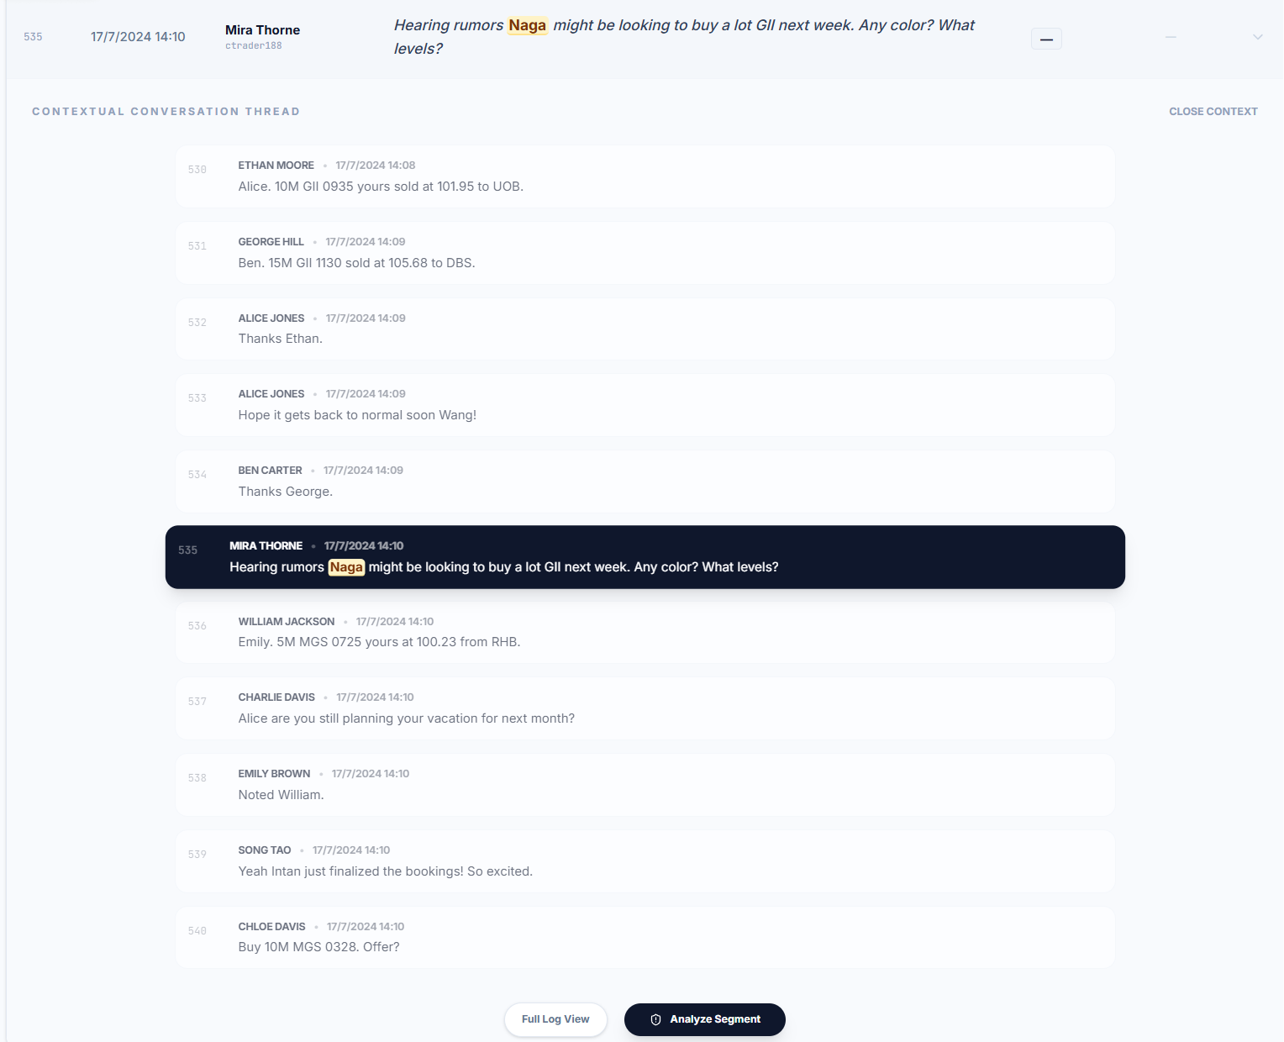
Analyze segment function will produce an analysis by AI:
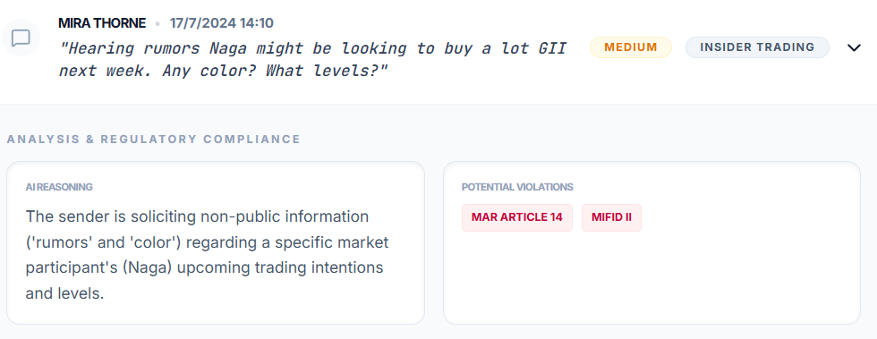
Analysis on message containing ‘askar’:
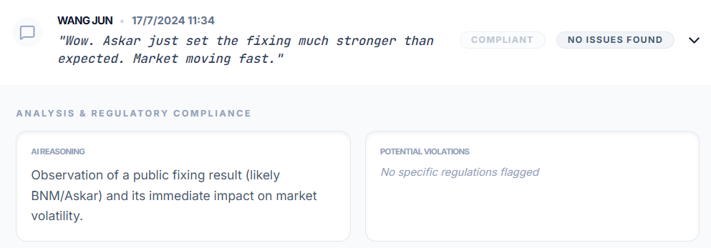
The app identified this messages to be false alarm.
Example of positive misconduct identified using other codeword ‘strawberry’:
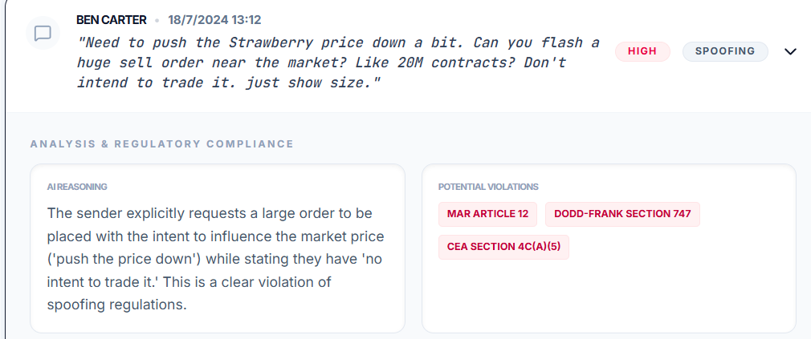

2. Misconduct Keywords
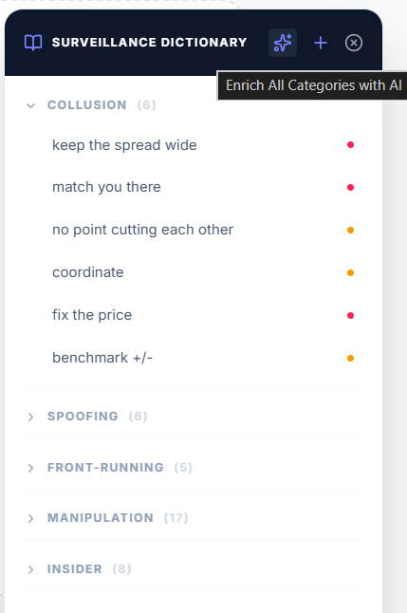
The TradeGuard app has an integrated dictionary containing a list of keywords categorised according to the types of potential misconducts. These keywords are clickable to give immediate search results from the uploaded message log. The dictionary can be updated using AI or by mannually adding/removing categories and keywords.

Lab Exercise 4:
In the given chat logs, what other misconduct modalities and events can you detect using Google AI Studio
- Show your technique
- Show your success/failure
- Comment on the effectiveness of these two approaches.

B3. Identify Messages Soliciting Information
A new dictionary category “Solicit Information” was created and populated with keyword using AI. Repeat the search and analyse processes from previous Lab Exercise to identify violations.
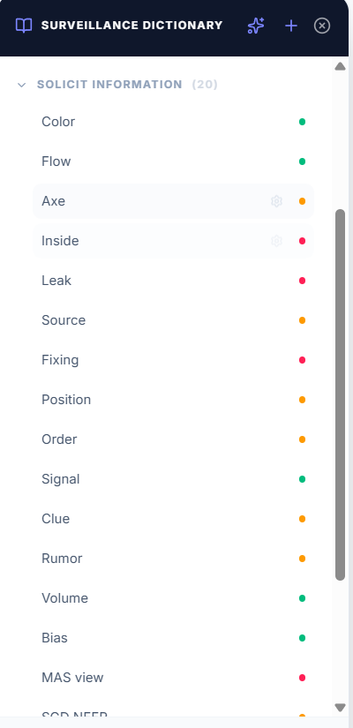
Example for positive case identified using keyword: mandate
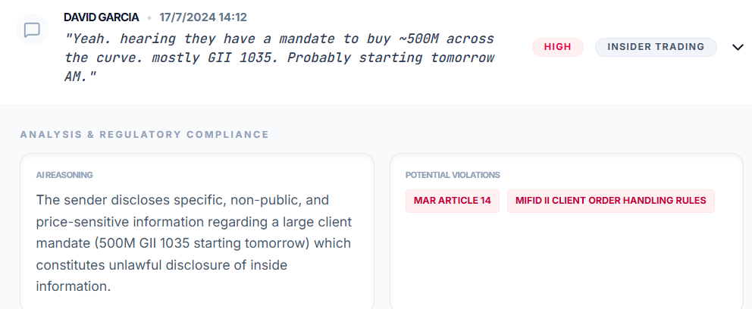

B4. Other Misconducts Identified
Results from a full scan of the documents done by the TradeGuard app developed using Google AI Studio:
Timestamp | Sender | MessageContent | ViolationType | Severity | Reasoning
2026-05-10T02:44:04.308Z | Shu Ting | Hey. got client order to sell 200M of the MGS 0730. They are price insensitive. just need to get it done. | Insider Trading / Confidentiality Breach | High | The trader discloses highly sensitive, non-public information regarding a massive 200M client order in MGS 0730, including the client's price-insensitive nature, which exposes the client to predatory trading.
2026-05-10T02:44:04.308Z | Bob Williams | Sell 10M of MGS 0730 at 102.5 | Front-Running | High | Following the leak of a 200M price-insensitive sell order, Bob Williams immediately places a 10M sell order for the same security, attempting to trade ahead of the anticipated downward price pressure caused by the larger order.
2026-05-10T02:44:04.308Z | Alice Jones | Hey. market's dead quiet on MGS 0735. Let's keep the bid/ask spread wide today? Maybe show 101-05 / 101-07? | Collusion / Price Fixing | High | Alice Jones proposes to another trader to artificially maintain a wide bid/ask spread on MGS 0735 due to low liquidity, which is an anti-competitive practice that harms market efficiency and client pricing.
2026-05-10T02:44:04.308Z | Intan Niaga | Yeah sounds good. No point cutting each other's throats. I'll match you there. Keep it wide. | Collusion / Price Fixing | High | Intan Niaga explicitly agrees to the proposal to fix wider spreads, confirming the collusive agreement to avoid competitive pricing ('No point cutting each other's throats').
2026-05-10T02:44:04.308Z | David Garcia | Yeah. hearing they have a mandate to buy ~500M across the curve. mostly GII 1035. Probably starting tomorrow AM. | Insider Trading / Confidentiality Breach | High | David Garcia discloses a specific client's (Naga) 500M mandate across the curve, specifically mentioning the GII 1035 bond. This is material non-public information that gives other traders an unfair advantage.
2026-05-10T02:44:04.308Z | Mira Thorne | Thanks! shall adjust my position. lunch on me! | Front-Running / Insider Trading | High | Mira Thorne explicitly states she will 'adjust her position' based on the leaked confidential mandate of a major buyer, which constitutes trading on material non-public information.
2026-05-10T02:44:04.308Z | Ben Carter | Need to push the Strawberry price down a bit. Can you flash a huge sell order near the market? Like 20M contracts? Don't intend to trade it. just show size. | Spoofing / Market Manipulation | High | Ben Carter requests the placement of a 'flash' sell order of 20M contracts with no intent to trade, specifically intended to manipulate the price downward ('push the Strawberry price down').
2026-05-10T02:44:04.308Z | Mira Thorne | Sure. I'll layer some big offers above the market too. Let's see if we can spook the bids lower. Pull them quickly once price moves. | Spoofing / Market Manipulation | High | Mira Thorne agrees to coordinate spoofing by layering offers she intends to pull once the price moves, confirming the joint effort to manipulate market bids through deceitful orders.
2026-05-10T02:44:04.308Z | Intan Niaga | GII 0535 auction coming up. Heard Stanchart isn't bidding aggressively. How about we both submit bids slightly lower. say around 100.05 | Collusion / Bid Rigging | High | Intan Niaga proposes coordinating bid levels (100.05) for an upcoming government bond auction (GII 0535) to suppress price competition, which is a severe violation of auction integrity.
2026-05-10T02:44:04.308Z | Charlie Davis | Okay. I can work with that. Let's not drive the price up for ourselves. I'll stay around that level. | Collusion / Bid Rigging | High | Charlie Davis accepts the bid-rigging proposal for the auction to avoid driving up the price, confirming the anti-competitive coordination between market participants.

